Sample School

Being the best we can be

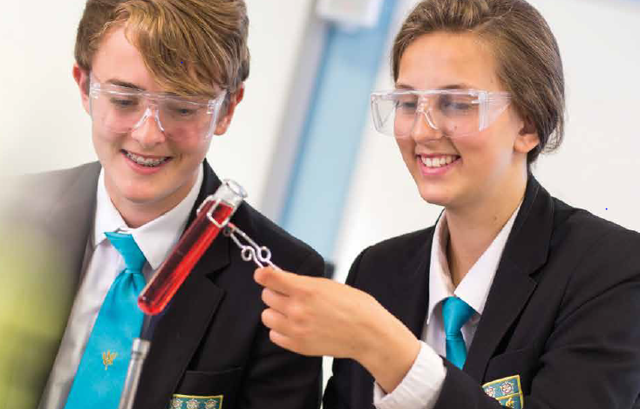

Teacher of Science
Required for January 2020
Recruitment Information Pack
Sample School
Sample Address

Contents

Welcome from the Headteacher 3
Our results 4
Our staff 5
Application process and how to apply 6
Career pathways 7
Our coastal offer 8
Job Description 9
Person Specification 10

Dear applicant,

Allow me to extend a warm welcome from all governors, staff and students of Sample School.

I was delighted to be appointed Headteacher in January 2018 and while any Head will say their school is special – I truly believe Sample is.

It is hard to encapsulate in words the full dynamism and vibrancy of our school. We are hugely proud of our students and privileged to serve them and this community. We see it as our professional and moral duty to prepare them as individuals to play their part as active citizens – rounded and centred and aware of all they might contribute to the world. In practical terms, this commitment is manifested in the lessons we deliver, the extra-curricular opportunities we offer and in the wider opportunities we promote.
Sample is a school with a strong academic tradition but we are equally committed to the Arts, to sport and to collective and individual achievement beyond the classroom. Our annual productions held at the XXX theatre are testament to this, and over the years we have seen productions of Macbeth, Romeo and Juliet, Our House to name but a few.
We have developed and benefited from our partnerships within Sample Learning Trust, Doncaster Teaching Alliance and local secondary and primaries – a few reasons to join us!

In recent years enormous strides have been made to further increase learning standards. This hard work has seen results improve consistently and led to Ofsted rating our school as ‘Good’ in 2012 and in 2019. I truly believe we are a school with highly effective teachers producing outstanding outcomes for our students.

I hope you can see that this is an excellent time to join Sample. If successful you will join a staff team of wonderful professionals who have ambition for our students and for themselves. I take pride in ensuring colleagues receive opportunities to develop their skills and experiences – and we have an enviable reputation for delivering high quality professional development.

I hope that you will take the time to come and see and experience for yourself the warm and welcoming atmosphere which makes our vision a reality.

Good luck with your application.

Sample
Headteacher

Our results

Sample School’s 2019 GCSE results are once again characterised by high levels of achievement.

Provisional analysis shows that, for the fourth year in a row, our students made significantly better progress than their peers did nationally. Results in English, Maths and Science are above the national averages at Grade 4 and Grade 5, with 36% of students achieving a Grade 7 or better in English, 28% achieving Grade 7 or better in Maths and 21% achieving Grade 7 or better in two sciences.

This year’s results are particularly pleasing because of the high number of students who achieved Grade 8 and 9 across a number of subjects.

None of these fantastic results would have been possible were it not for the professionalism and dedication of our teachers and learning support teams. These results mean that our students leave us now being able to access a wide range of post-16 courses at college and they have the skills and knowledge valued by employers.”

Our success in our GCSE results follows our positive Ofsted inspection in February this year. With a similar Progress 8 score to 2018, which places us in the top 20% of schools nationally, we are delighted that the high quality of education on offer has been doubly validated at a national level.

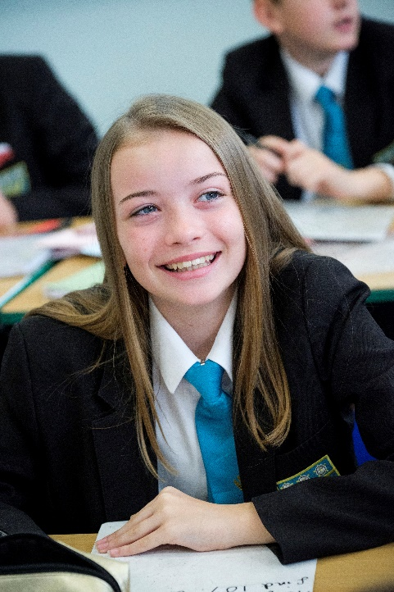
Our staff

Emma Smith is a teacher of Mathematics at Sample School in Doncaster. She has worked at Sample since September 2018.

What do you enjoy most about your job?

I just love coming to work every morning, my school is fantastic; amazing teachers, lovely students and a fantastic community to work in. I qualified as a PE specialist but when I came for an interview for a PE teacher, I was offered a job as a maths teacher. When I weighed up my options for this there was no real choice to be made. The welcoming feel of the school and the staff and children in it just made me feel like I belonged right from the start, and I still feel this way a year later.

What’s the best thing about the community that your school serves?
I think that the community this school is in is lovely, I do commute to work so I do not live in the area but the community is involved in the school and the school is involved in the community. I think that is something that is quite rare and it makes Sample School even more special.

What would you say to a teacher thinking about moving to a school on the Doncaster?

I think there is something unique about Doncaster schools, the environment they create is something of a community, and everyone is working together towards a shared goal. I have a 50-60 minute drive to work every day and if I did not love the school or the location, I would find it a struggle. However, it is the complete opposite. I adore the school and therefore the drive is not a problem for me.

Application Process
The closing date for all applications is 9am on Friday 4th October 2019.

Interviews will be held as soon as possible after the closing date.

Completed applications must be returned to Heather Christmas at; heather.christmas@northyorks.gov.uk

If you do not receive confirmation of receipt of your application within one working day please call Heather on 01609 536933

If you think you’re the person for the job, please complete the enclosed application form with a covering letter, no more than two sides of A4, and send to the email address above by the closing date.

An email will be sent to shortlisted candidates with details of the interview process. If you have not heard from us within a week of the closing date please assume your application has been unsuccessful.

Queries
Visits are warmly welcome. Please contact Heather to arrange.

We actively welcome you to contact Heather at Resourcing Solutions NYES to chat through the role and talk informally about the school/post and how working here will make a real difference to the children and young people in Doncaster.

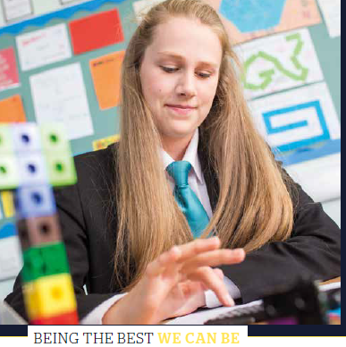

Career pathways
We believe in growing the very best teachers and leaders through:
- An outstanding ‘Sample School Standard’ professional development programme for staff at all stages of their career to help ensure the highest levels of standards in the classroom.
- An incremental coaching and development programme for all staff and ongoing training in the use of formative assessment.
- Opportunities for continued leadership development.
- We also have a specific programme for middle leaders who have ambitions to develop further in a whole school or leadership post in the future.
A career progression pathway for a new member of staff joining Sample School as an NQT or as an experienced member of staff may involve:
Year 1
- Partnership with a lead teacher in your department – for weekly mentor meetings with NQTs and peer coaching with more experienced staff adapting to their new school
- Comprehensive CPD programme – with initially weekly events to accelerate progress during your first term in your new school and a continuing programme of bespoke opportunities throughout the year

Years 2 & 3 – Where the progress the teacher is achieving from students is solidly good
- Opportunity to take on increased leadership responsibility within your subject area. We have a specific RQT programme for example.
- Invite to participate in one of our school and Trust CPD programmes.
- Opportunity to apply to become a Specialist Leader in Education within our Trust or within the Local Authority.

Our Offer

There are no great schools without great teachers - the key to education is the person at the front of the classroom.

This is an exciting time in which to join our professional body of teachers across the Doncaster Opportunity Area. Our schools are thriving and with such a sense of community and partnership, a modern way of working has allowed us to collaborate and work in partnership so that we can adapt and evolve.

We are part of the Doncaster Opportunity Area that is prioritising improvements to education and numeracy and literacy outcomes, alongside a drive to recruit and retain high-quality, motivated teachers to the area - what are you waiting for?

Teachers like you have the opportunity in the Doncaster region to be supported to have an enriched career that remains attractive to you as your career and life develops. We recognise and have developed a range of distinctive opportunities to give you the confidence to engage in additional professional and leadership development, as well as access to fully-funded national professional qualifications.

We value good teaching and great teachers in Doncaster. That is why we have developed our ‘Offer’ - which is in addition to your existing pay and rewards package offered by your school, academy or multi-academy trust.

Job Description

JOB TITLE: Teacher of Science

RESPONSIBLE TO: Head of Science

RESPONSIBLE FOR: Deployment of support staff allocated (where relevant)

JOB PURPOSE: Promote effective learning, appropriate student achievement and educational, social and personal progress of all pupils for whom the teacher is designated as being responsible, consistent with the aims of the school and the unique needs of each individual.
KEY RESPONSIBILITIES:

1. Develop and maintain an up-to-date knowledge and understanding of the areas of teaching and student support for which post-holder is responsible

2. Plan work to meet the learning needs of allocated pupils in a consistent and effective way

3. Use appropriate teaching and classroom management strategies to motivate pupils and enable each to progress appropriately

4. Monitor the progress of students for whom the postholder is responsible to set expectations and give constructive feedback

5. Maintain appropriate records to demonstrate progress made by students

- Participate fully in professional development activities to develop practice further, sharing the learning from these as appropriate

- Make an active contribution to the policies and aspirations of the school

8. Safeguarding and Promoting the Welfare of Students

Working with the Designated Child Protection Person the post holder will:

- Identify and record any child protection concerns
- Contribute information as required for Common Assessment or Multi-Agency meetings
- Act at all times in line with the school’s Child Protection procedures.

9. To Comply with the School Policy on Health and Safety
10. To fulfil all of the responsibilities and duties required by the school’s policies
on Teaching and Learning.
11. To achieve any performance criteria or targets arising from the School’s
Performance Management arrangements
12. To fulfil all of the requirements and duties set out in the current Pay and Conditions Documents relating to the conditions of employment of teachers
Person Specification

JOB TITLE: TEACHER
CRITERIA | ESSENTIAL | DESIRABLE | ASSESSMENT
Qualifications | - Qualified Teacher Status | - Degree  - National Governing Body Awards
Experience | - Experience of Key Stage 3/4 and the use of PLTS.  - Experience of planning and delivering curriculum at relevant KS and/or subject(s) | - Experience of teaching in more than one school | - Application form  - Interview
Knowledge | - A thorough knowledge and understanding of all relevant aspects of the National Curriculum in relation to the post | - Willingness to engage in CPD activities in relation to learning and teaching | - Application form
Personal Qualities | - Ability to relate to and build relationships with pupils, parents and other members of the school community  - Enthusiasm and commitment to the aims and objectives of the school  - Good communication skills  - Take a full and active role in the extra curricular programme | - Willingness to participate fully in school life | - Interview  - Application form  - Reference

