St Martins Church of England VA Primary School

Headteacher Job description

‘Serve one another in love’
Galatians 5v13
Job purpose

In the light of the school’s Church of England foundation and its commitment to sustaining and developing its Christian ethos and values, the purpose of the role of Headteacher at St Martin’s School is:

- To be an inspirational leader who is called, connected and committed to deliver the St Martins School vision for the children, staff and community it serves.

- To lead by example, actively modelling and embedding into all areas of school life, the Christian vision and core Christian values of the school ensuring a life in all its fullness for all.

- Deliver and ensure an enriched and high-quality curriculum which delivers high standards, expectations and outcomes for all pupils.

- To undertake the expectations of a Headteacher as set out in the October 2020 Headteacher Standards.

- To promote and enhance the wellbeing of the team, developing a distributed leadership, nurturing opportunities for all staff to learn and grow to their full potential.

- To further develop relationships with our families and the wider community to enhance the contribution to school life and outcomes and opportunities for children.

Main Responsibilities

The main responsibilities of the role are based upon meeting and upholding the National Headteacher Standards and the Christian vision and values that are an integral part of our school ethos.

As Headteacher you will be a practicing Christian, who will actively live out and embed the Christian vision and core Christian values of the school, in accordance with the tenets of religious denomination of the school. (i.e. belonging to a church in membership of Churches Together in Britain and Ireland).

Figure: Headteacher Standards, October 2020

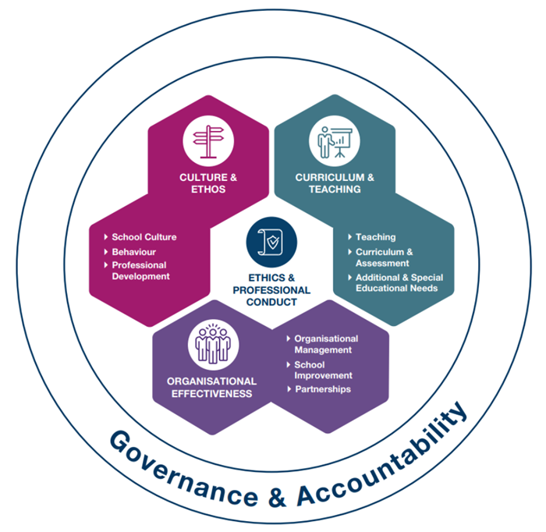

The Headteacher will:

- meet and uphold the Headteacher Standards which clearly set out the expectations of the role of Headteacher.

- hold, articulate and demonstrate a clear Christian vision, values and moral purpose. Firmly rooted in the Christian faith respecting cultural diversity and focussed on providing a rich relevant curriculum where children can flourish, widen their horizons and aspire to be the best that they can be.

- demonstrate the Christian vision and values of the school in everyday working practice through optimistic personal behaviour, building positive relationships and attitudes towards
pupils and staff, and towards parents, governors and members of the wider community. Rooted in mutual respect and ensuring proper professional boundaries and treating each person as a unique individual of inherent worth.

- be responsible for working in close partnership with the Governing Body and Diocese to ensure the vision for the school is delivered.

- ensure other members of the leadership team and individuals within the school have an opportunity to develop their leadership qualities and experience.

- achieve coherence across professional standards by ensuring some alignment of the Headteacher Standards with the current teachers’ standards and the early career framework. This will mean that teachers and leaders will receive consistent and complimentary messages about good practice.

- know, understand and act within statutory frameworks which set out professional duties and responsibilities, giving account and accepting responsibilities.

- lead, monitor and evaluate SMSC across all areas of school life and develop the spiritual life of the school.

- lead, monitor and evaluate and develop collective worship and Religious Education as a core subject.

- manage the financial and human resources effectively and efficiently to achieve the school’s Christian vision and values in line with legal requirements.

- sustain current and wide knowledge and understanding of education and school systems locally, nationally and globally.

- regularly review own practice and achievements, set personal targets and take responsibility for own personal and professional development, taking account of any feedback.

General

- The above principal accountabilities are not exhaustive and may vary without changing the character of the job or level of responsibility.

- The postholder must be flexible to ensure the operational needs of the school are met. This includes the undertaking of duties of a similar nature and responsibility as and when required, throughout the various work areas in the school.

- The Health and Safety at Work Act (1974) and other associated legislation places responsibilities for health and safety on all employees. Therefore, it is the postholders responsibility to take reasonable care for the Health, Safety and Welfare of him/herself and other employees in accordance with legislation and the schools Health and Safety policy and procedures.

